1)Functions selected and the reason for their selection:

1. **StripString(str): StringUtils.java**  
   Selected for the simplicity of thinking and implementing the boundary value analysis
2. **SetClipboardContent(Str): ClipboardUtil.java**

The particularity on this class is that the method does not return any value so to check its functionality we need to check the status of a singleton object. Another particularity, that function 1 and 2 do not presented, is that this method throws an exception when there is no graphics display (which is not our case).

1. **StripNonValidXmlCharacters(Str) String.java**Selected because it was more challenging to perform the analysis in this particular function given the values that he could or not take.

2)Purpose of each function:

1. **StripString(str): StringUtils.java**  
   The purpose of this function is to make large text smaller. To do it, if the text has more than 80 characters the program returns a string with the first 80 characters and three dots at the end.
2. **SetClipboardContent(Str): ClipboardUtil.java**

The purpose of this function is to put a text on the system clipboard. If the text is null or empty the function will put an empty text but if the clipboard is inaccessible an exception will be thrown.

1. **StripNonValidXmlCharacters(String) String.java**  
   The Purpose of this function is to replace non-human readable characters by a question mark character (“?”) using the Unicode corresponding to them.

3) Step-by-step boundary value analysis:

1. Invalid class: Null values

Off point: 0

0n point: 1

In points: X >= 1

Out points: X <= 0

1. Invalid class: Null values

Off point: 0

0n point: 1

In points: X >= 1

Out points: X <= 0

1. The numbers were converted to decimal to make it easy

In points: [… , 8] /\ [11, 12] /\ [55295, 57343] /\ [65534, 65536] /\ [1114112, …]

Out points: [9, 10], [32, 55295] /\ [57344, 655533] /\ [65536, 1114111]

Decimal : label

- 8: on point 1

- 9: off point 1

- 10: off point 2

- 11: on point 2

- 12: on point 3

- 13: off point 3

- 14: on point 4

- 31: on point 5

- 32: off point 5

- 55295: off point 6

- 55296: on point 6

- 57343: on point 7

- 57344: off point 7

- 65533: off point 8

- 65534: on point 8

- 65535: on point 9

- 65536: off point 9

- 1114111: off point 10

- 1114112: on point 10

4)Description of the unit tests:

1. **stripString (Str): StringUtils.java**
   1. Parameterized unit test method using all the inputs that are not null and another test method to test the null case using NullSource annotation.
2. [**SetClipboardContent**](https://pmd.github.io/pmd-6.49.0/pmd_rules_java_errorprone.html#returnemptycollectionratherthannull)**(Str): ClipboardUtil.java**
   1. Parameterized test using MethodSource annotation to provide the arguments and its expected result as one of the inputs is a null.
3. **testStripNonValidXMLCharacters (str): StringUtils.java**
   1. Parameterized test using MethodSource annotation to provide the arguments and its expected result as one of the inputs is a null.

5) Unit tests result analysis

**stripString (Str): StringUtils.java**

All test cases passed has expected:

* Zero characters (empty string) – return empty string
* Exactly 80 characters it should return the 80 characters has they are
* Exactly 81 characters should return 80 characters + “…”

[**SetClipboardContent**](https://pmd.github.io/pmd-6.49.0/pmd_rules_java_errorprone.html#returnemptycollectionratherthannull)**(Str): ClipboardUtil.java**

All test that should pass passed and the one that should fail failed:

* Zero characters (empty string) – should fail since it has to be equal or greater than one to succeed
* Exactly 1 character - passed since it has to be at lest one character long to be able to use itUma imagem com texto

  Descrição gerada automaticamente

**StripNonValidXMLCharacters (str): StringUtils.java**

Test passed: Are the ones that are off points they passed because they are valid xml characters

Test failed: Are the ones that are on points and they should fail since they are not valid xml characters

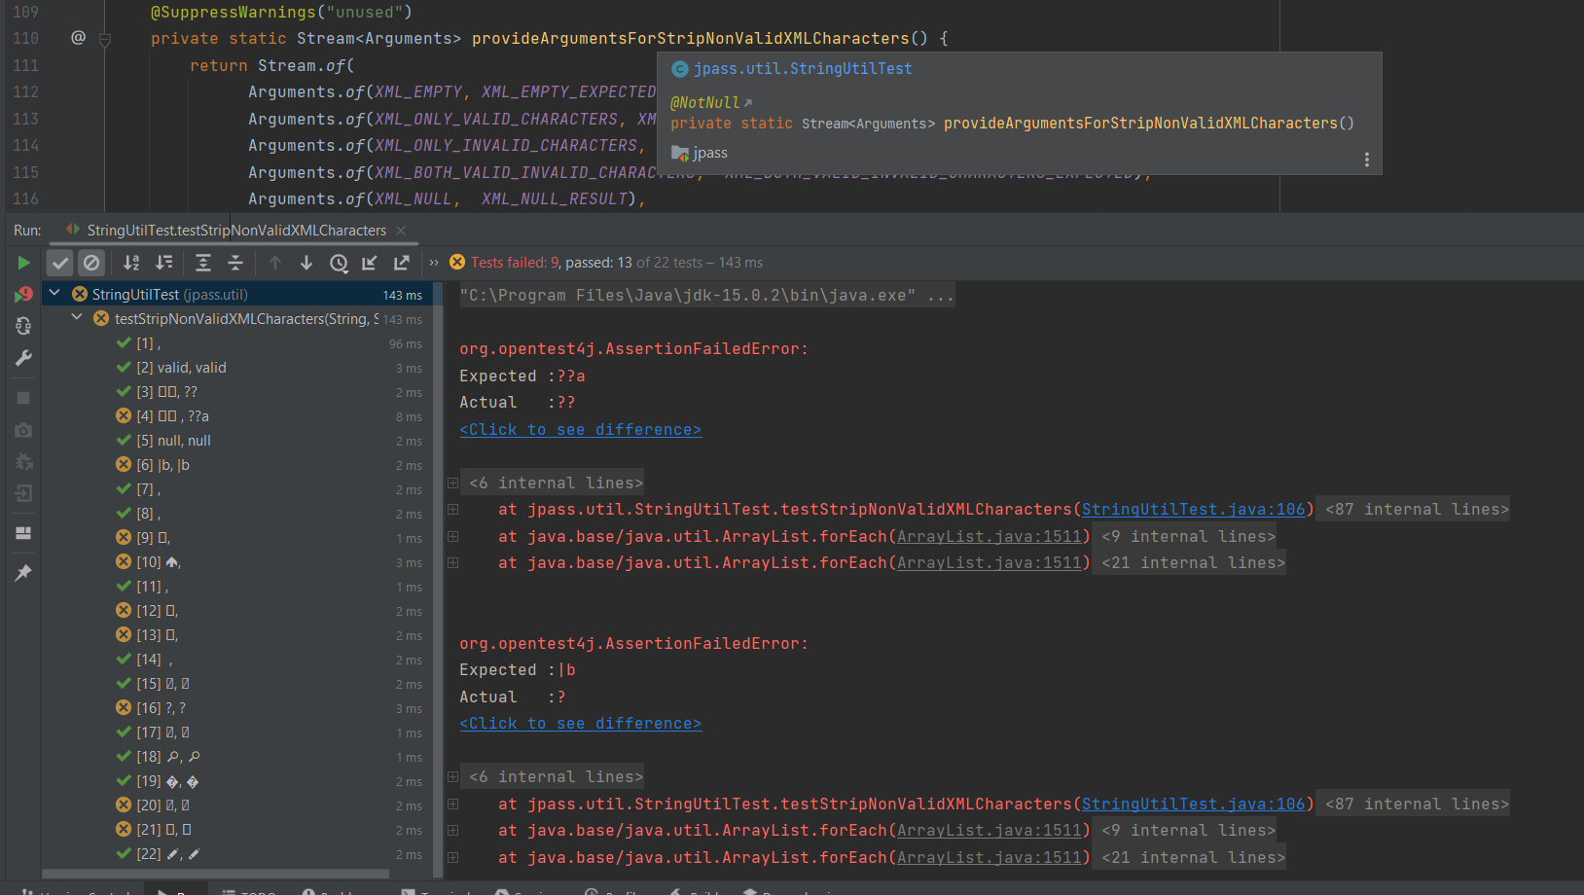

6) Analysis board

